Physical Education and Healthy Schools Newsletter
Autumn Term 2018/19

What a fantastic term of PE and School Sport across the Wye Forest Federation!

Our lessons, after school clubs and inter school competitions have really challenged the children to learn about movement, dance, rugby, hockey, football, dodgeball, and lots more.

The children across the Federation, and I, have put together this newsletter to share all the highlights of the term with you.

Information on this year’s Sports Premium Spend will be published very soon on both school’s websites. The document will show this year’s action plan, initiatives that have already been started and the impact of those against the 5 key Sports Premium DfE outcomes to date. Our aim of this year’s Sports Premium Spending across the Federation is to increase every teacher’s confidence to plan, deliver and assess Physical Education and alongside this, to increase the breadth of our PE curriculum, offering our pupils the widest, most engaging, positive PE experience they, and we, are proud of!

Take a look at the work we’ve been doing and please let us know what you think at the next parent forum in 2019!

The Daily Mile – Across the Federation – Healthy Schools initiative

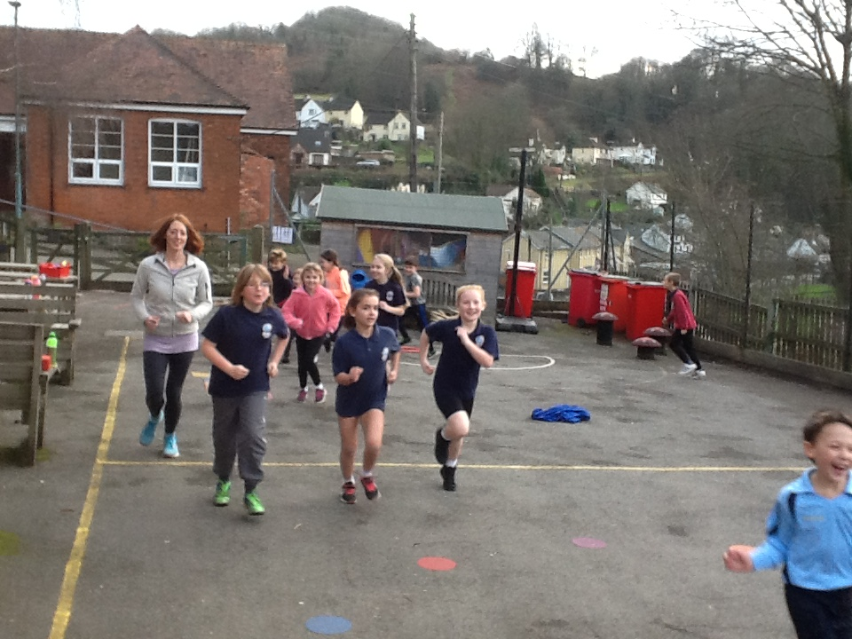

For more information about the Daily Mile Foundation and it’s aims please visit:
https://thedailymile.co.uk/

WW1 Dance – PE Curriculum

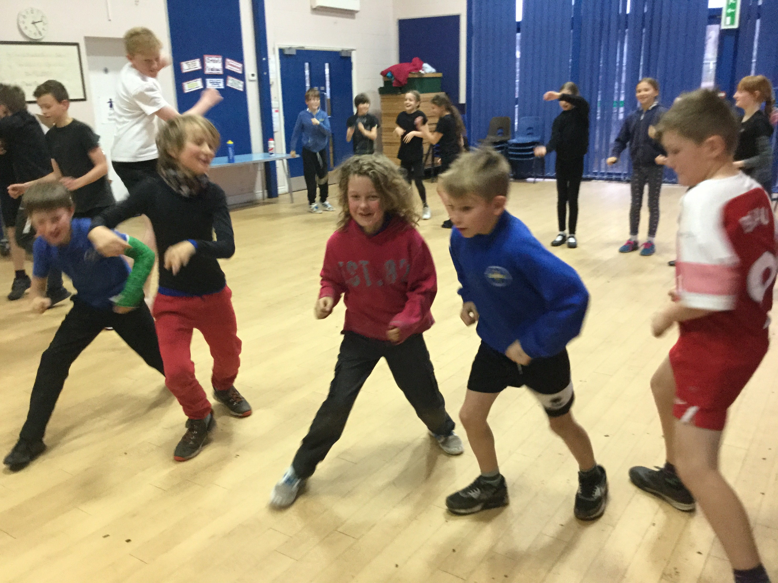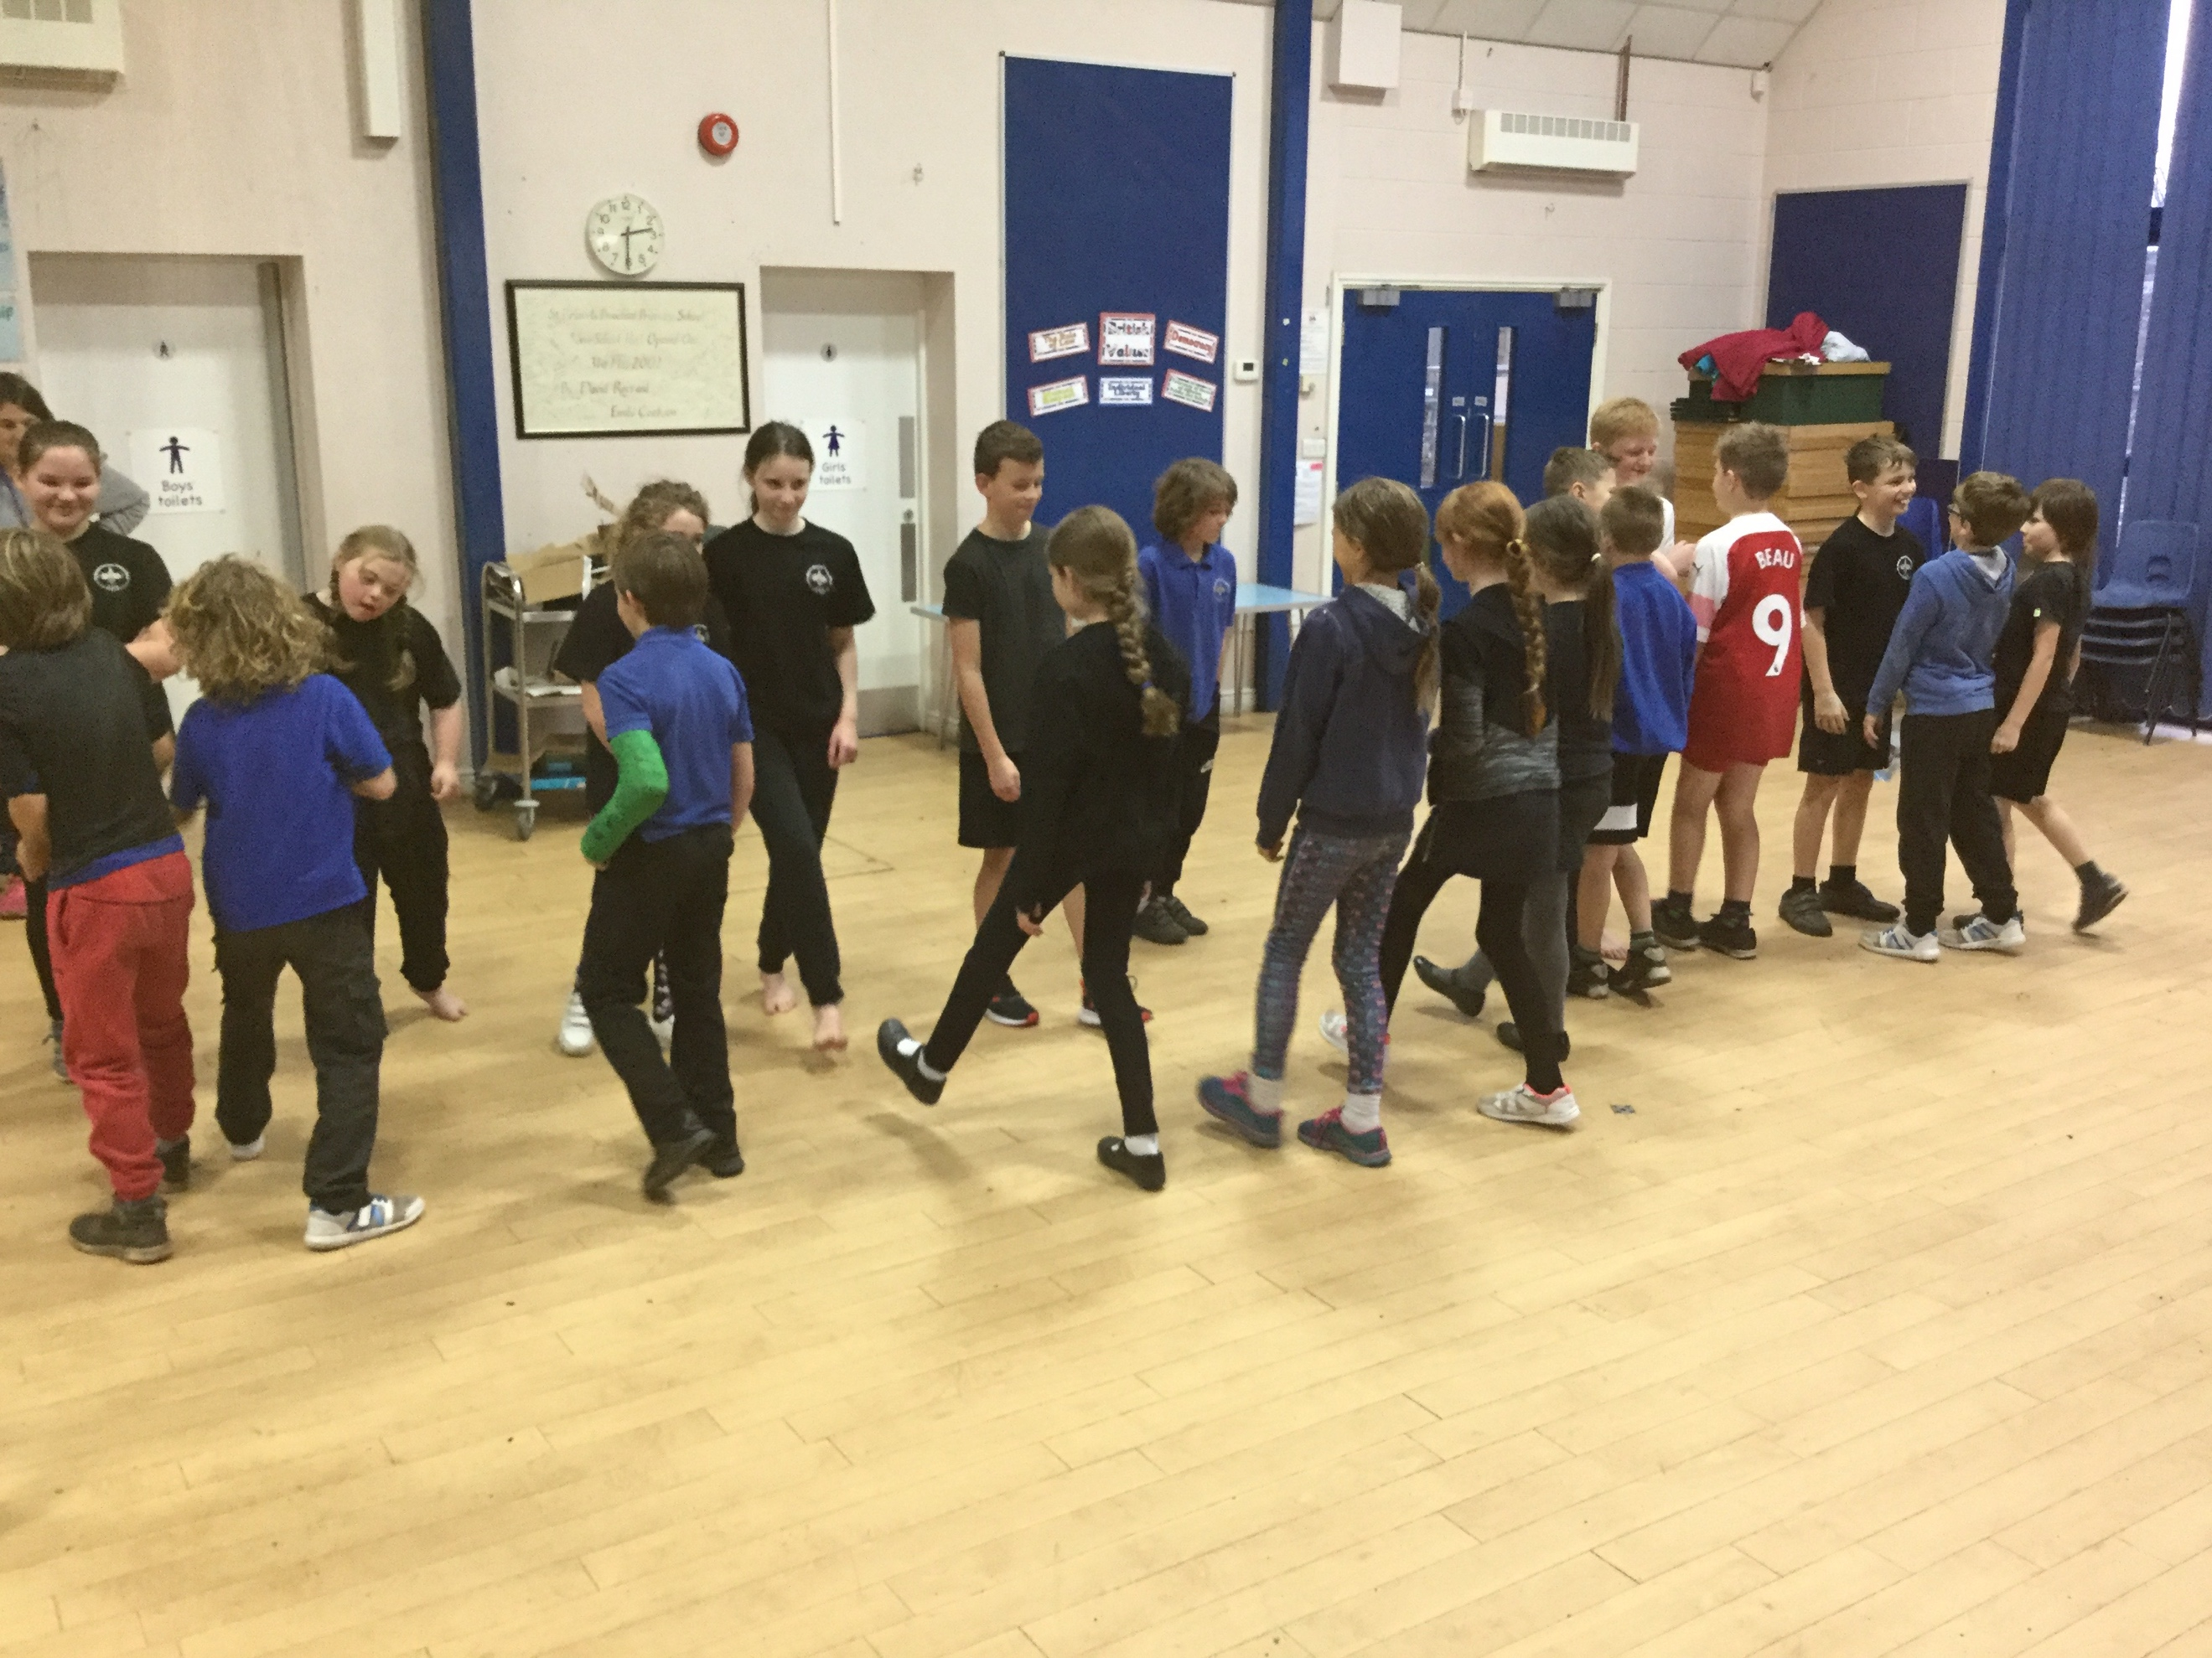

If any of your children are interested in dancing outside of school, please take a look at these community clubs here:
http://www.allsteps.co.uk/
https://www.facebook.com/Studio-16-2122784291322627/

Tag Rugby – PE Curriculum

Redbrook Taster session Didi Rugby 3.12.18

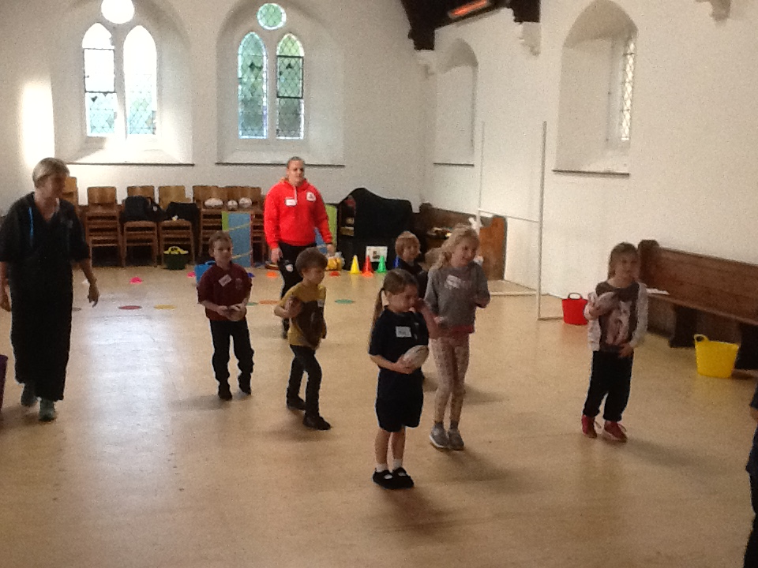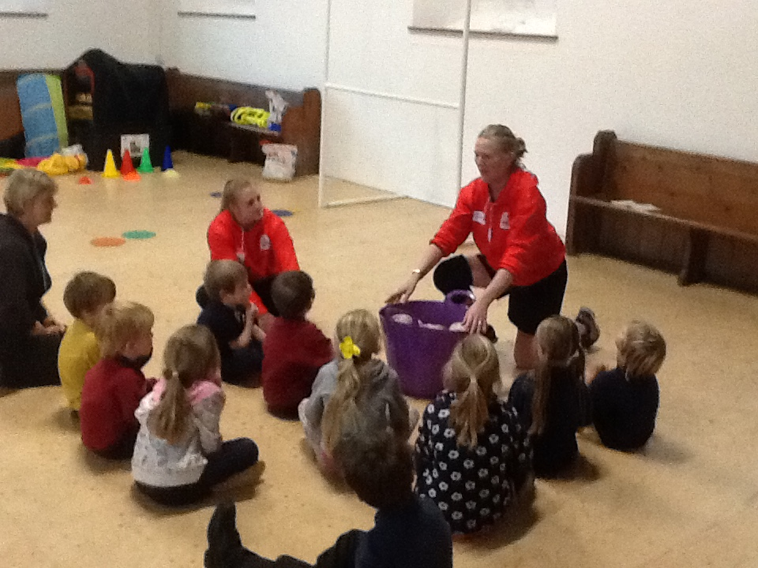

If your child enjoyed their Tag Rugby lessons this term, or enjoyed the Tag Rugby taster session with Didi Rugby, further information about community club, can be found here:

http://didirugby.com/ - Club based at Lydney
https://www.monmouthrfc.com/young_rugby - Club based at Monmouth
Didi Rugby taster sessions will take place at St Briavels during the Spring Term

Quick Sticks Hockey – School Games event

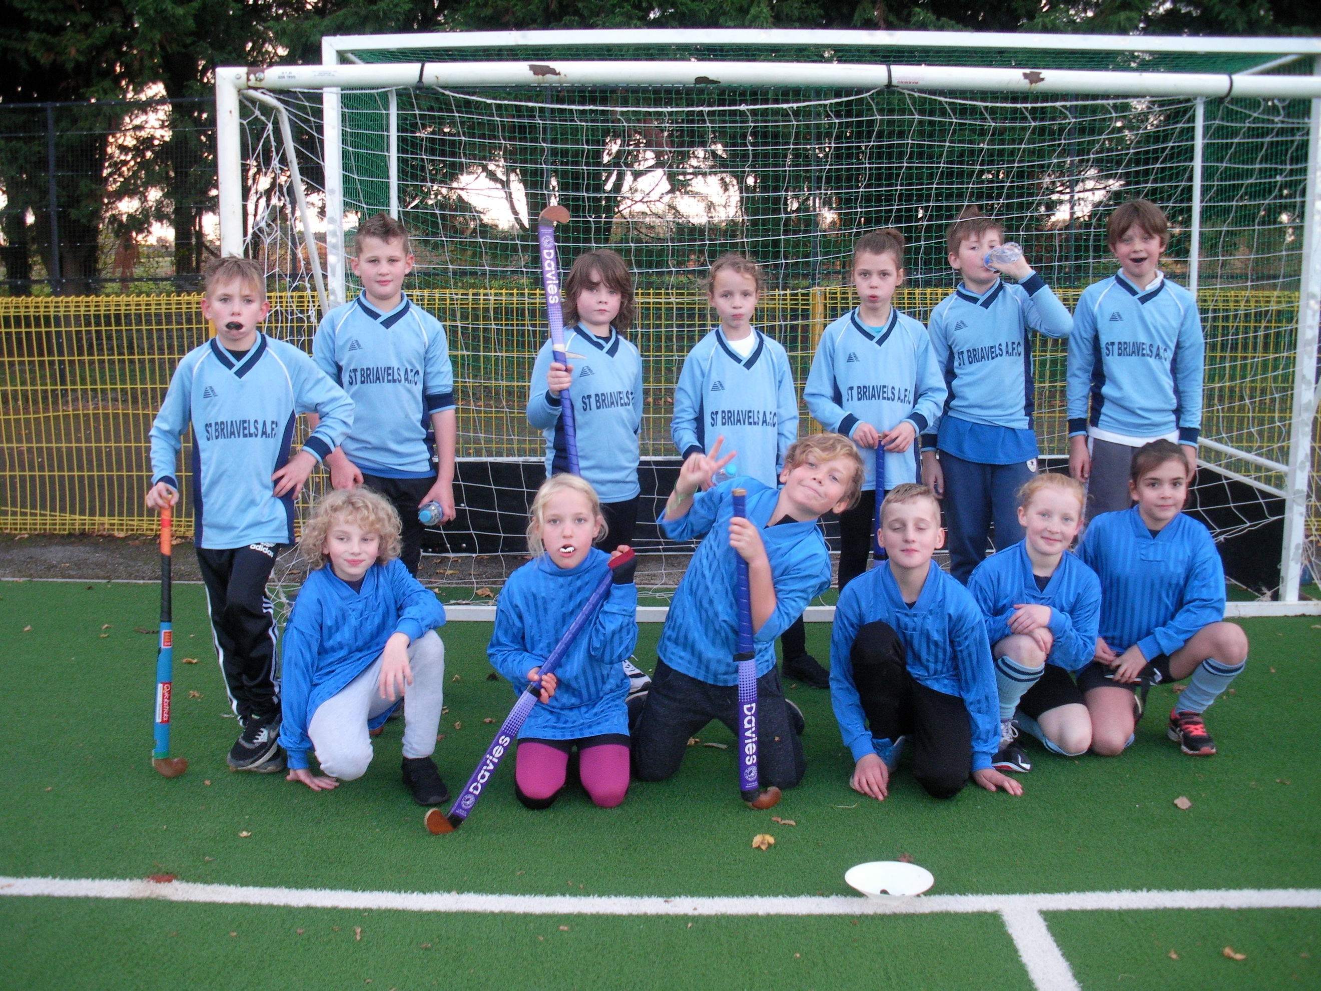

If your child really enjoyed themselves at the quick sticks hockey event, details of a community clubs can be found here:
https://lydneyhockey.wordpress.com – Lydney Hockey Club
http://rosshockey.org.uk/ross-junior/
- Ross Hockey Club who train at Monmouth Sports Centre

Cross Country – Whole Federation Competition

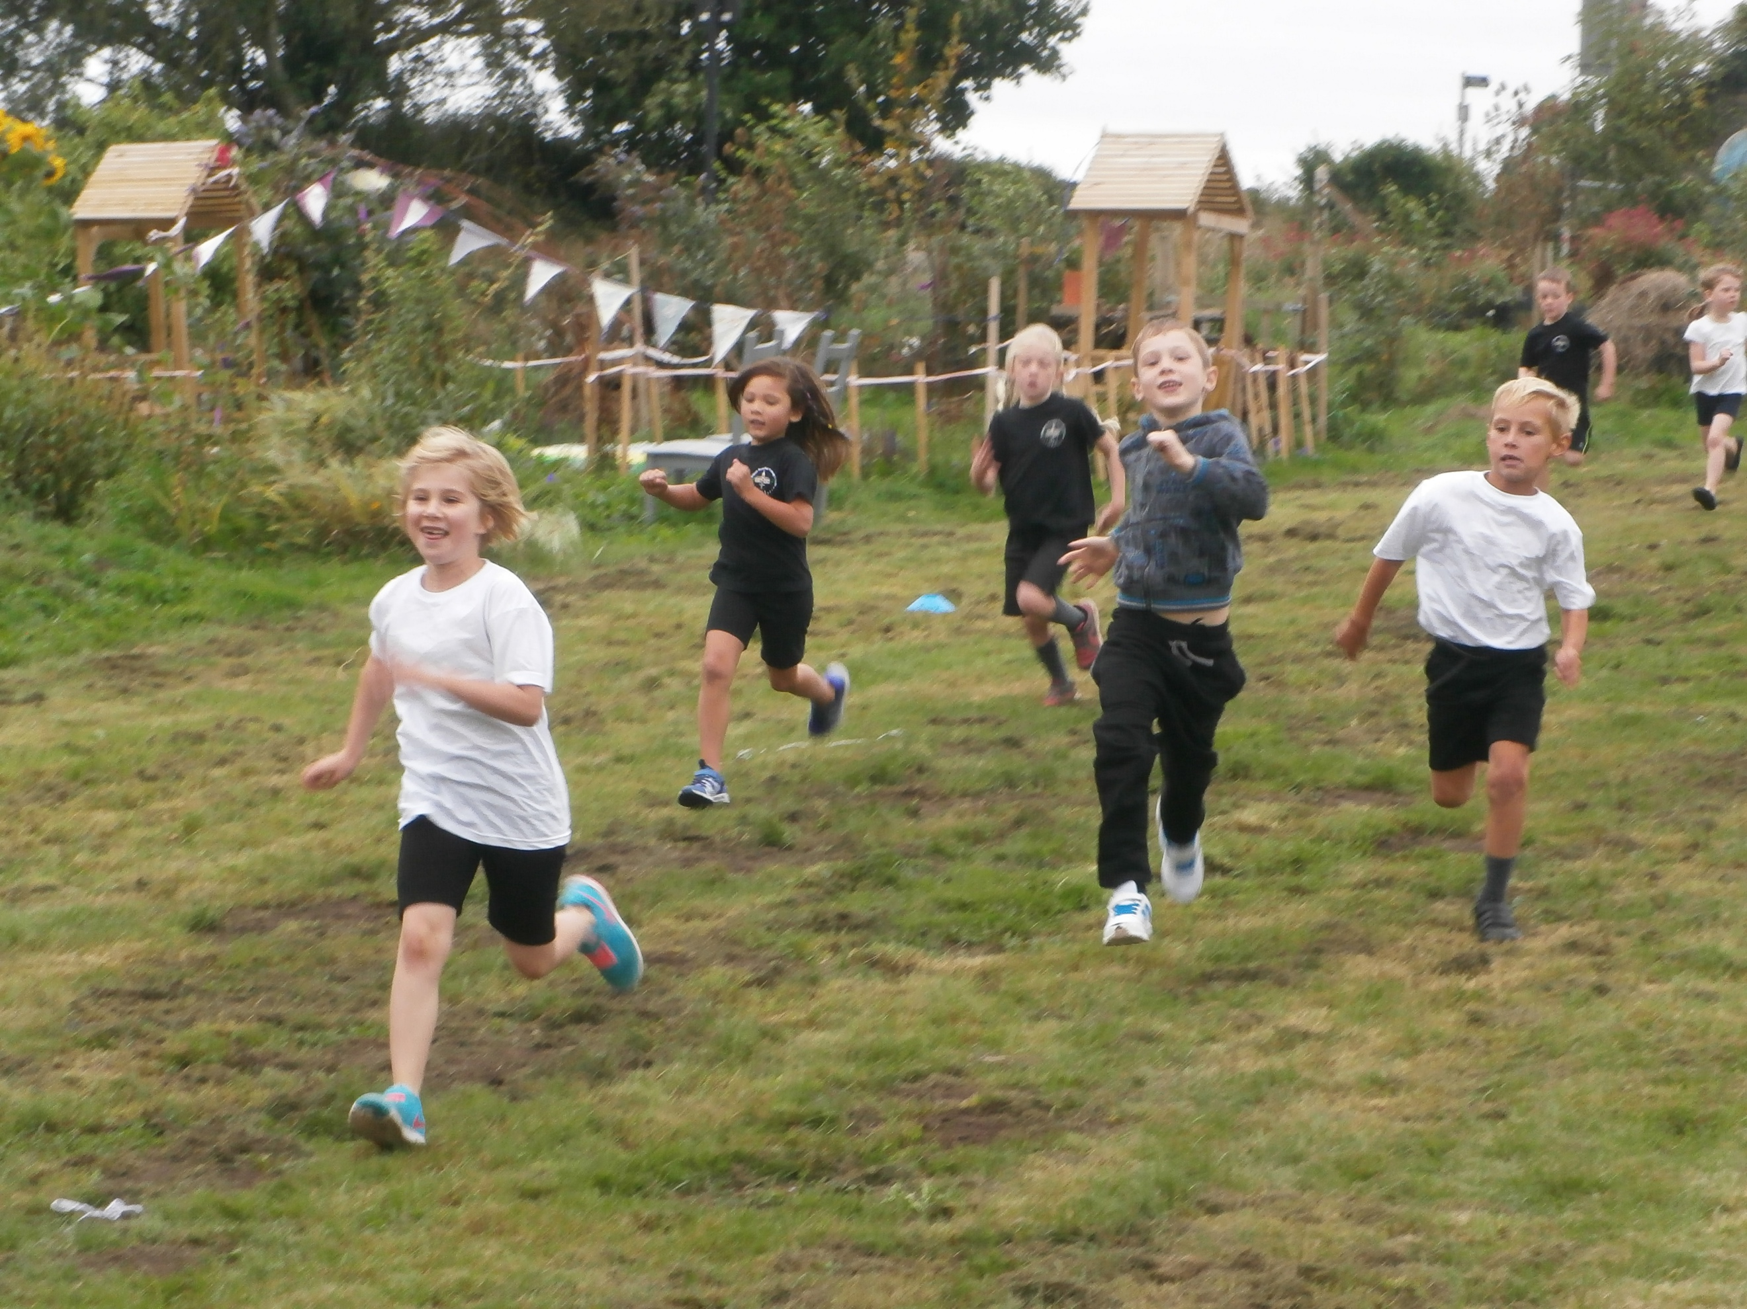

Anyone interested in joining a community club linked to cross country, here is some information.

Forest of Dean Athletics Club Training Sessions
Saturdays: Usually School years reception to year 8 – Fun, Friendship & Competition
The sessions on Saturday mornings run between 9.00am and 10.30am at Five Acres Athletics Track, Five Acres High School, Berry Hill near Coleford. It only costs £1 and you only pay when you come. The emphasis is placed upon fun, fun, fun and of course, competition. We meet every week during term time and school holidays, please come along and have a go. In the summer we are outside and in the Winter we meet in the gym next to the track. PS. While your children are having fun why not come for a run yourself at the Forest of Dean parkrun. Every Saturday at 9am just across the road from the club. If you enjoy your time with us and wish to continue training, then we will ask you to join the club.
Tuesdays: Usually School years 4 to 12 – Competition, Fitness & Training
Tuesday sessions concentrate on essential skills, training tips, warm up, injury prevention, track etiquette and all the health and safety aspects of athletics. We welcome everyone, whatever their ability and encourage as many people as we can to compete for the club, whether you take a serious approach to competitive athletics or do it just for the fun of it. These sessions are also £1 and you only pay when you come, however, like with Saturday sessions, if you enjoy your time with us and wish to continue training, we will ask you to join the club. Again, we meet at Five Acres Athletics Track, Berry Hill, near Coleford during term time and the holidays between 6.15pm and 7.30pm.
Cross Country – School Games Event (Five Acres High School)

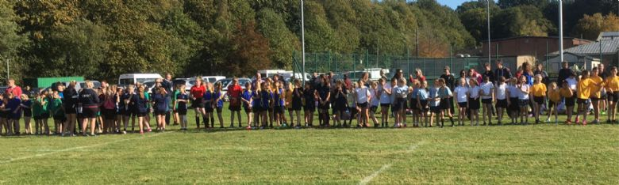

Children who took part said:
‘It was fun, tiring, but fun! It was exciting to be there for the first time. The best bit was finishing, laying down and pouring water over my head’.
Tae Kwon Do – Taster Sessions

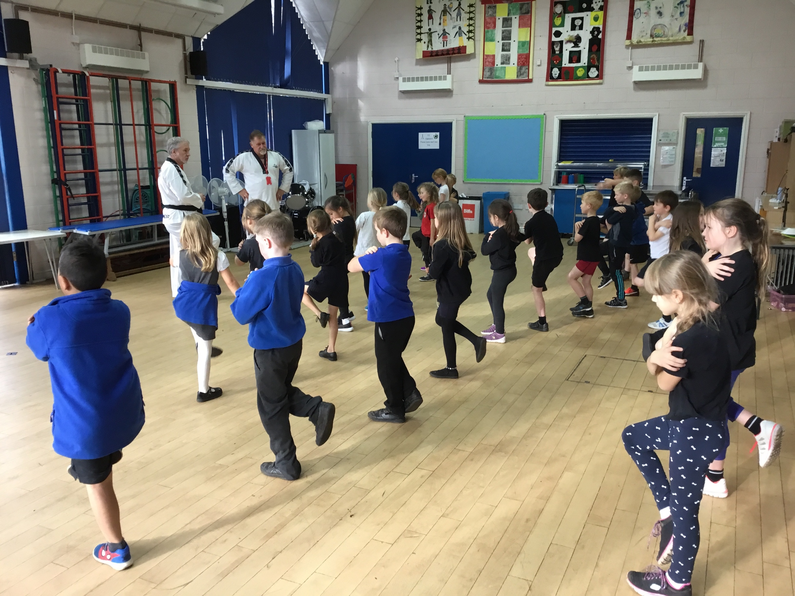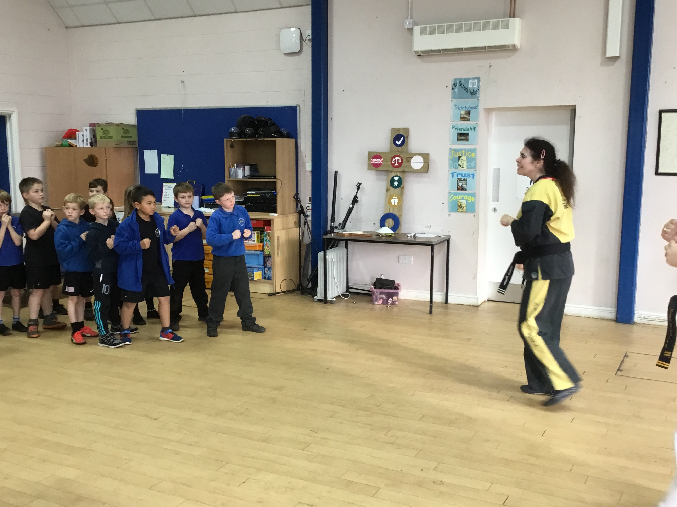

For further information on community clubs available:

Cinderford & Longhope TKD is on Facebook:
https://www.facebook.com/TAGBCinderford/ and Twitter and Instagram, @TAGBCinderford. Also, our website is www.cinderfordtkd.co.uk .
Monmouth TKD is on Facebook at https://www.facebook.com/groups/185648234942417/ and Lydney TKD can be found here: https://www.facebook.com/lydneytaekwondo/

Positive Playtime Practice & Wellbeing/Play Leader Training – Healthy Schools initiative

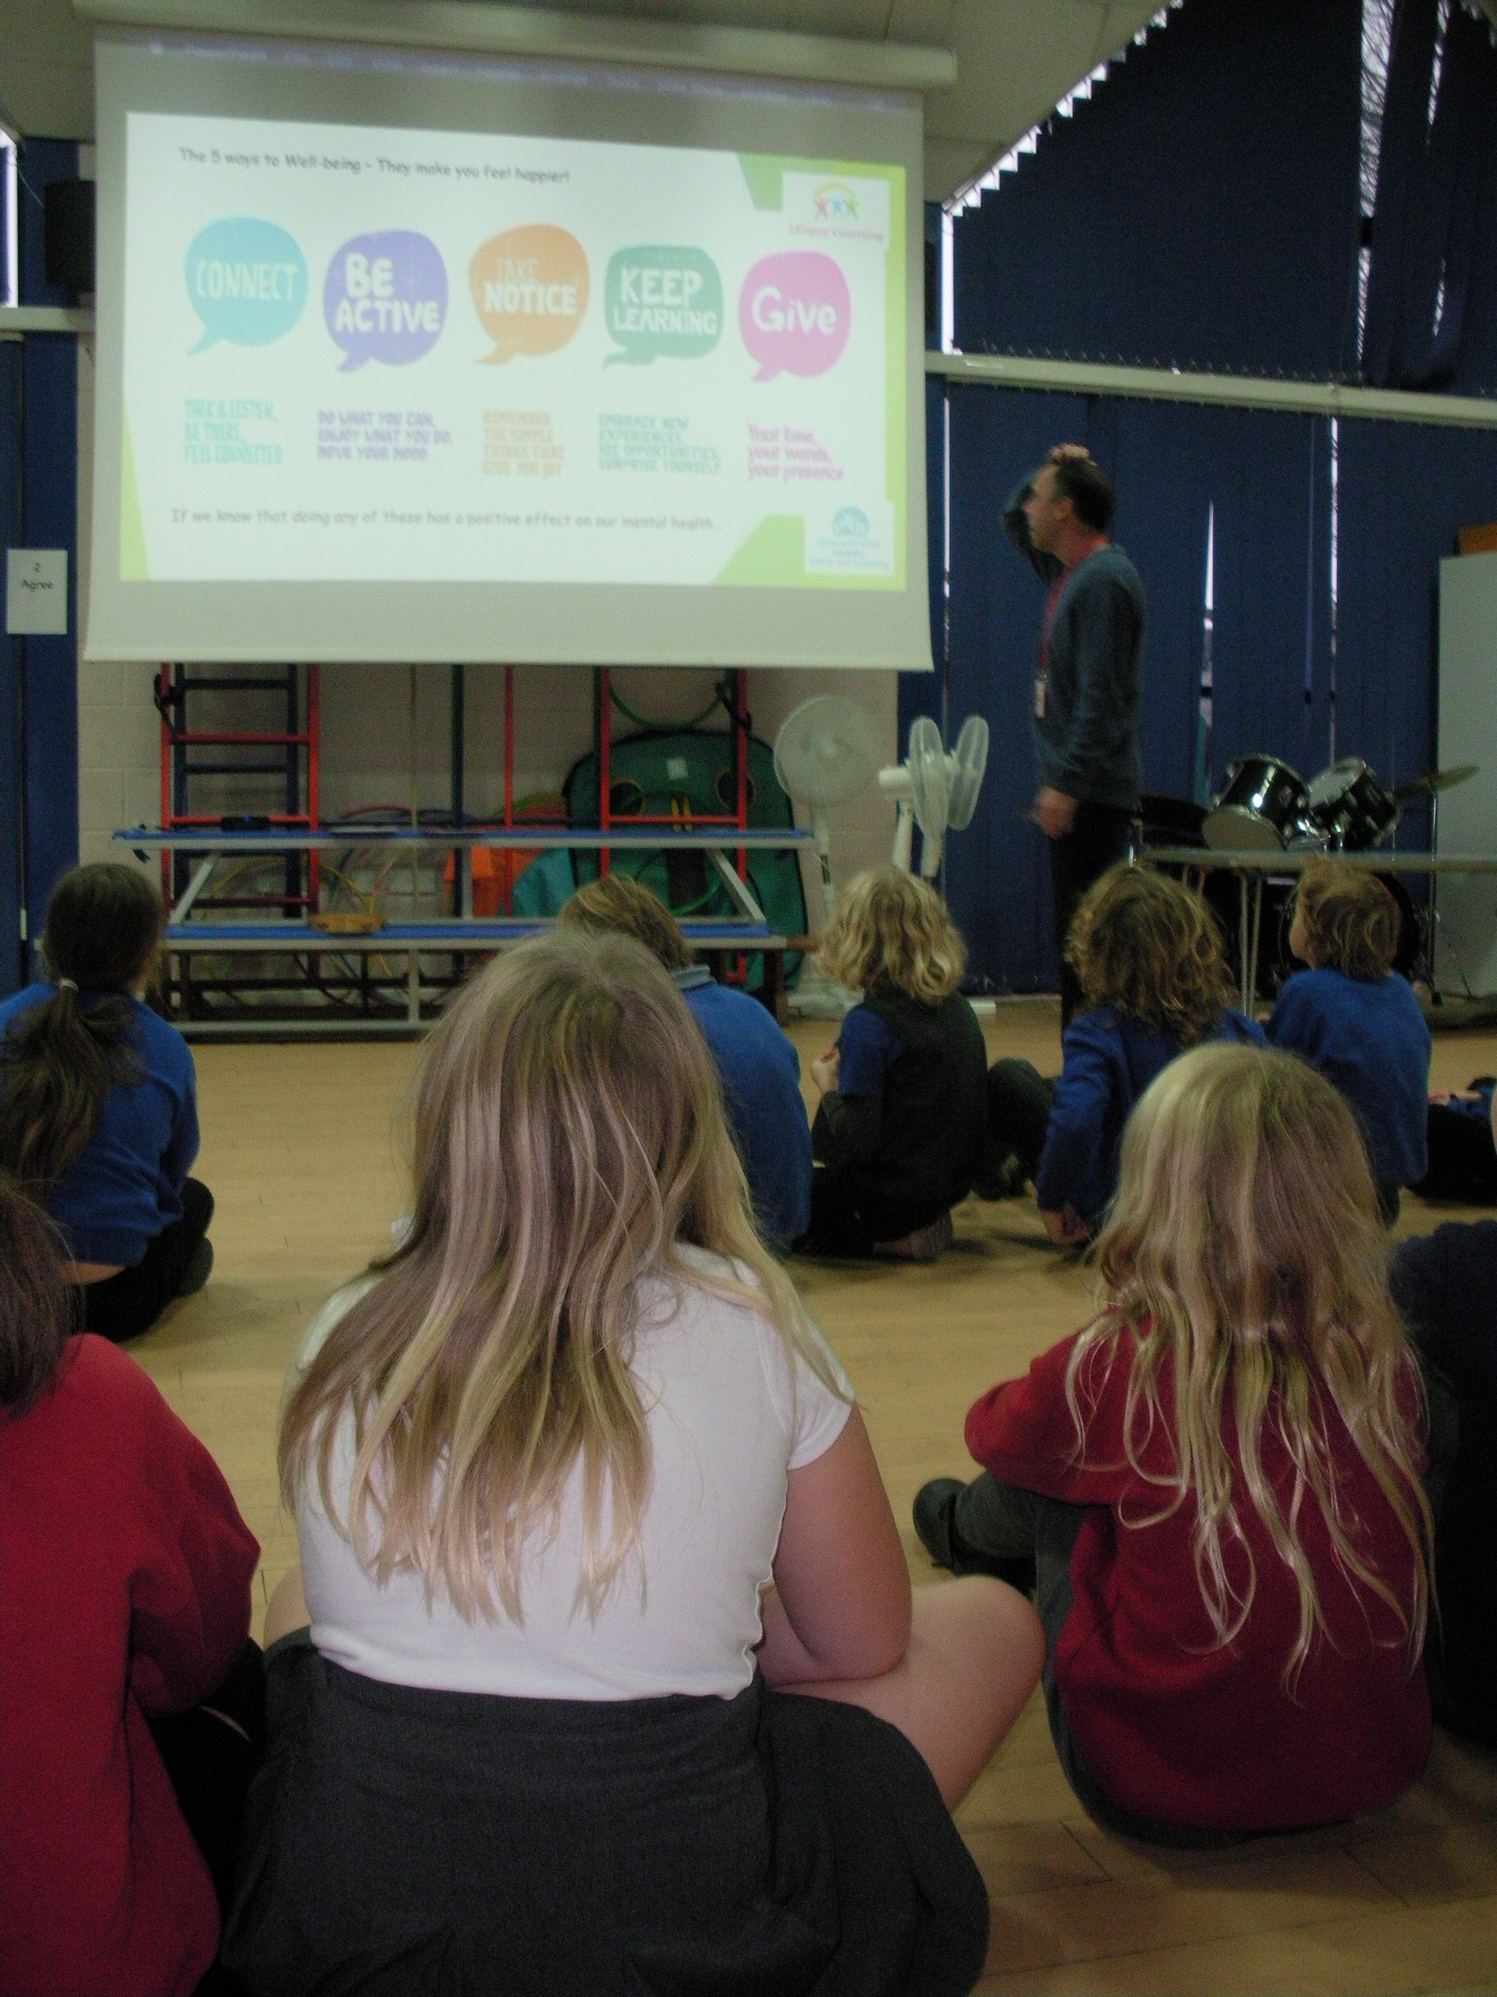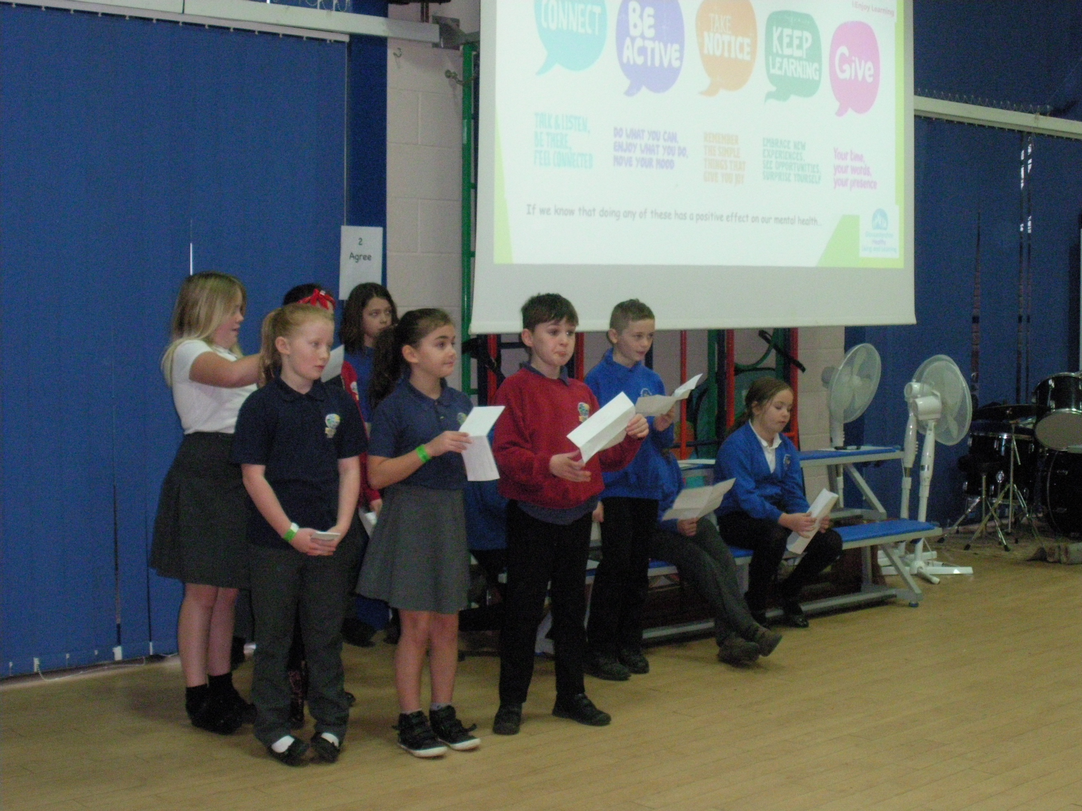

From this training, focusing on wellbeing and playtime behaviours, both schools have created an action plan to bring the ‘5 Ways to Wellbeing’ to life at break and lunchtimes across the Federation. We aim to boost the wellbeing of all pupils at break and lunch time.

Hi 5 Netball – PE Curriculum

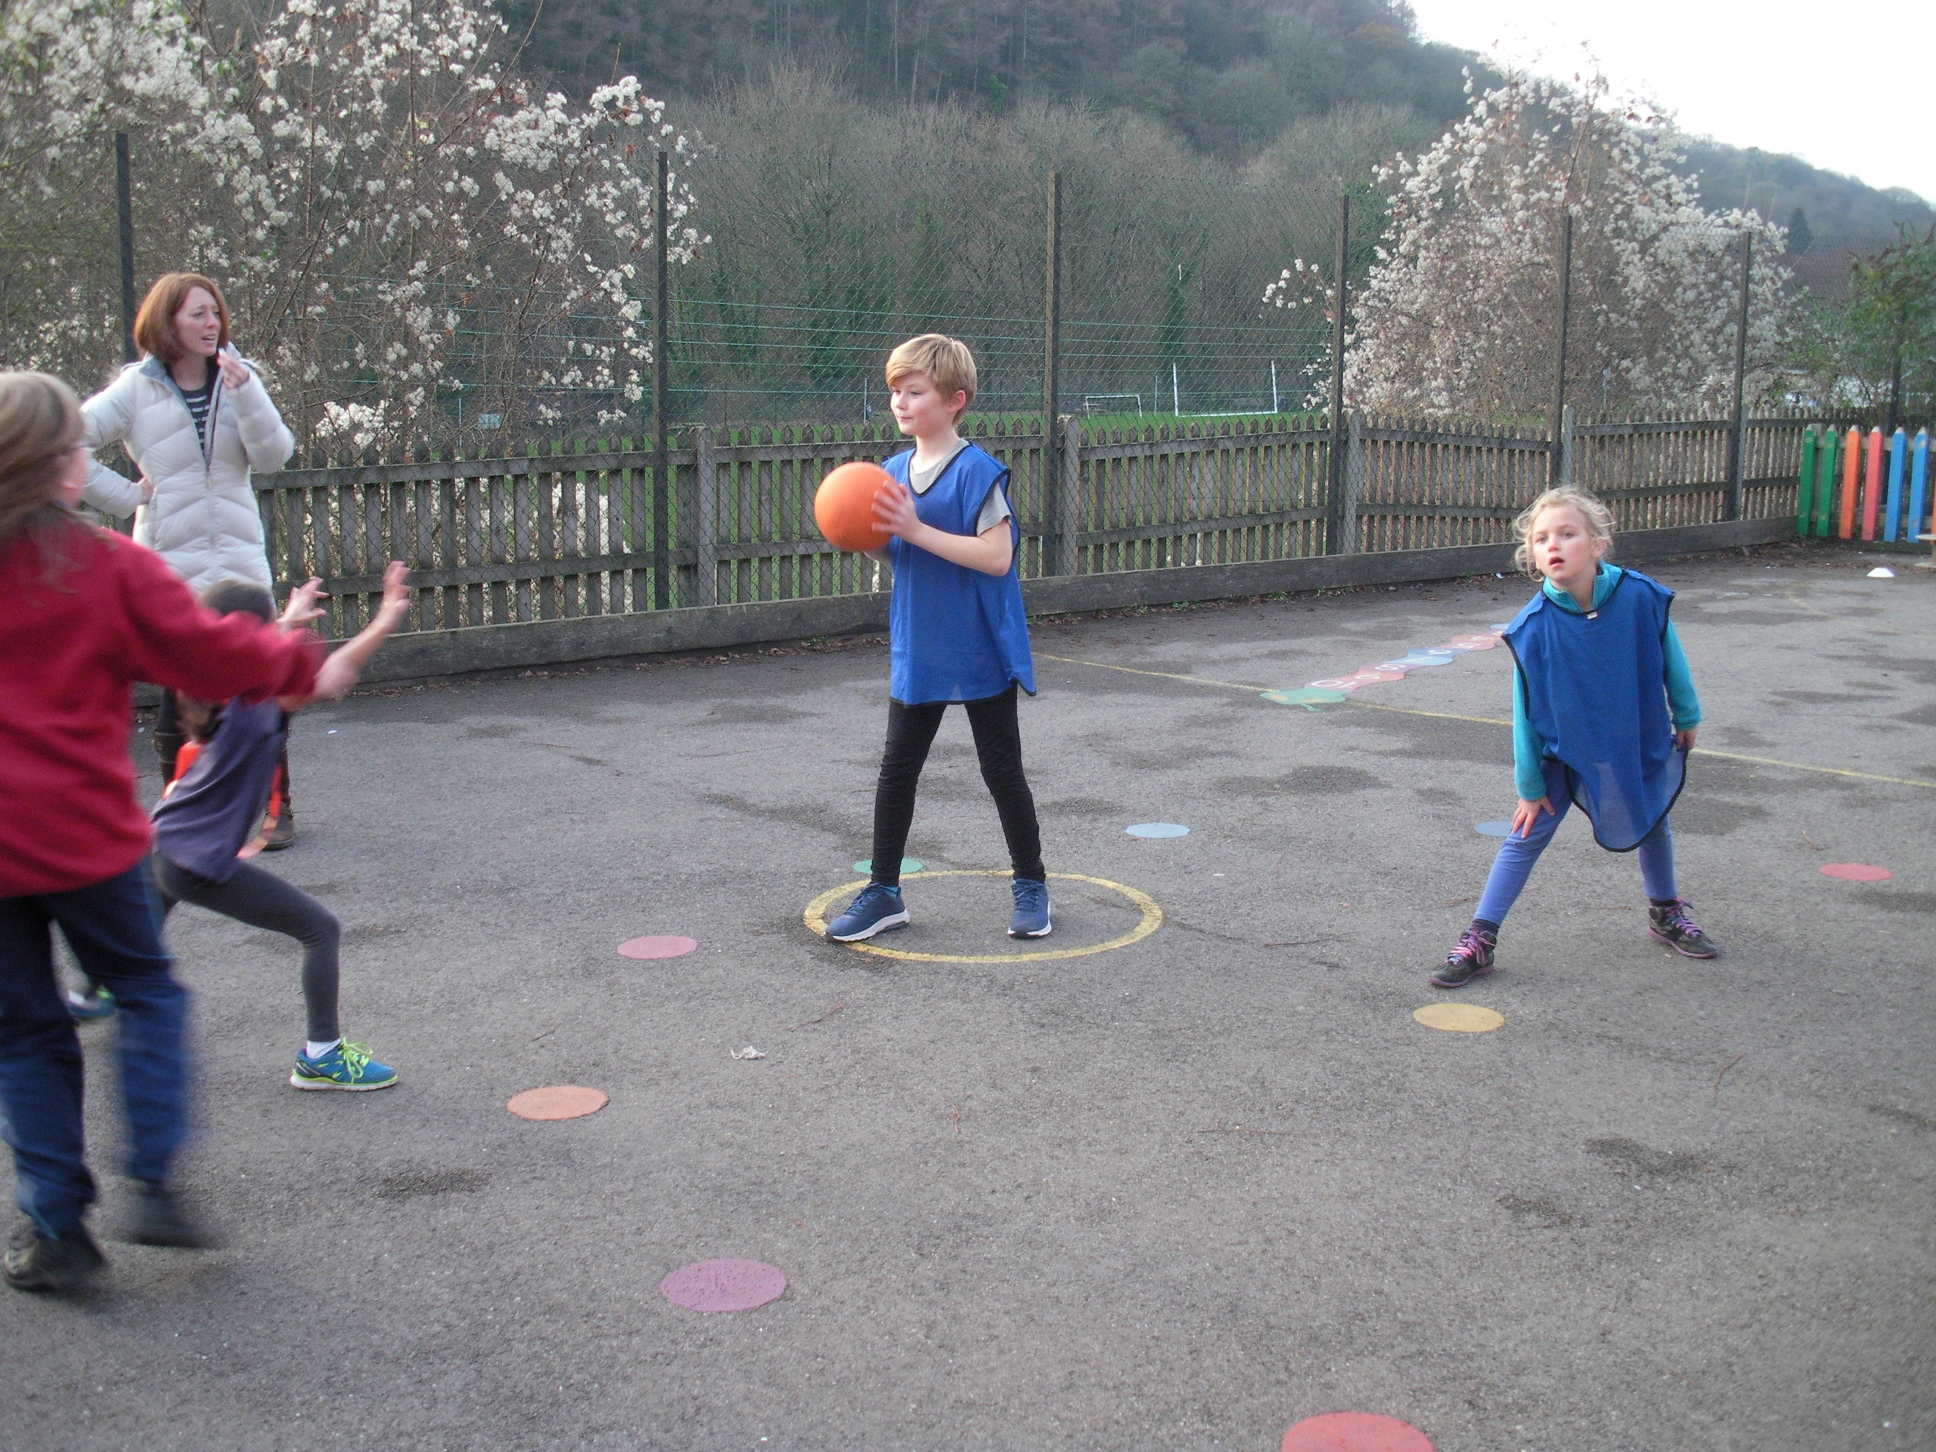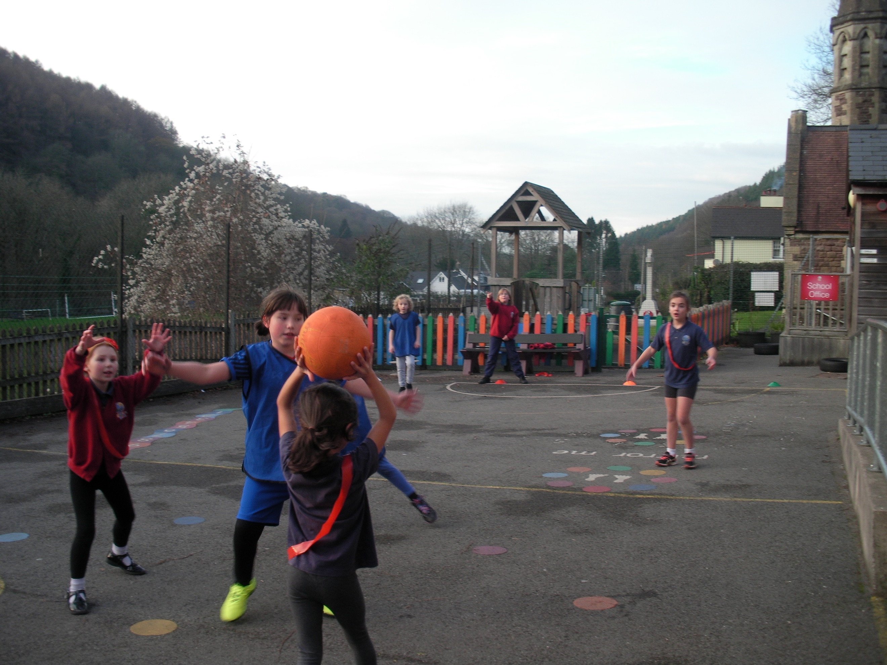

KS1 Ball Skills – PE Curriculum

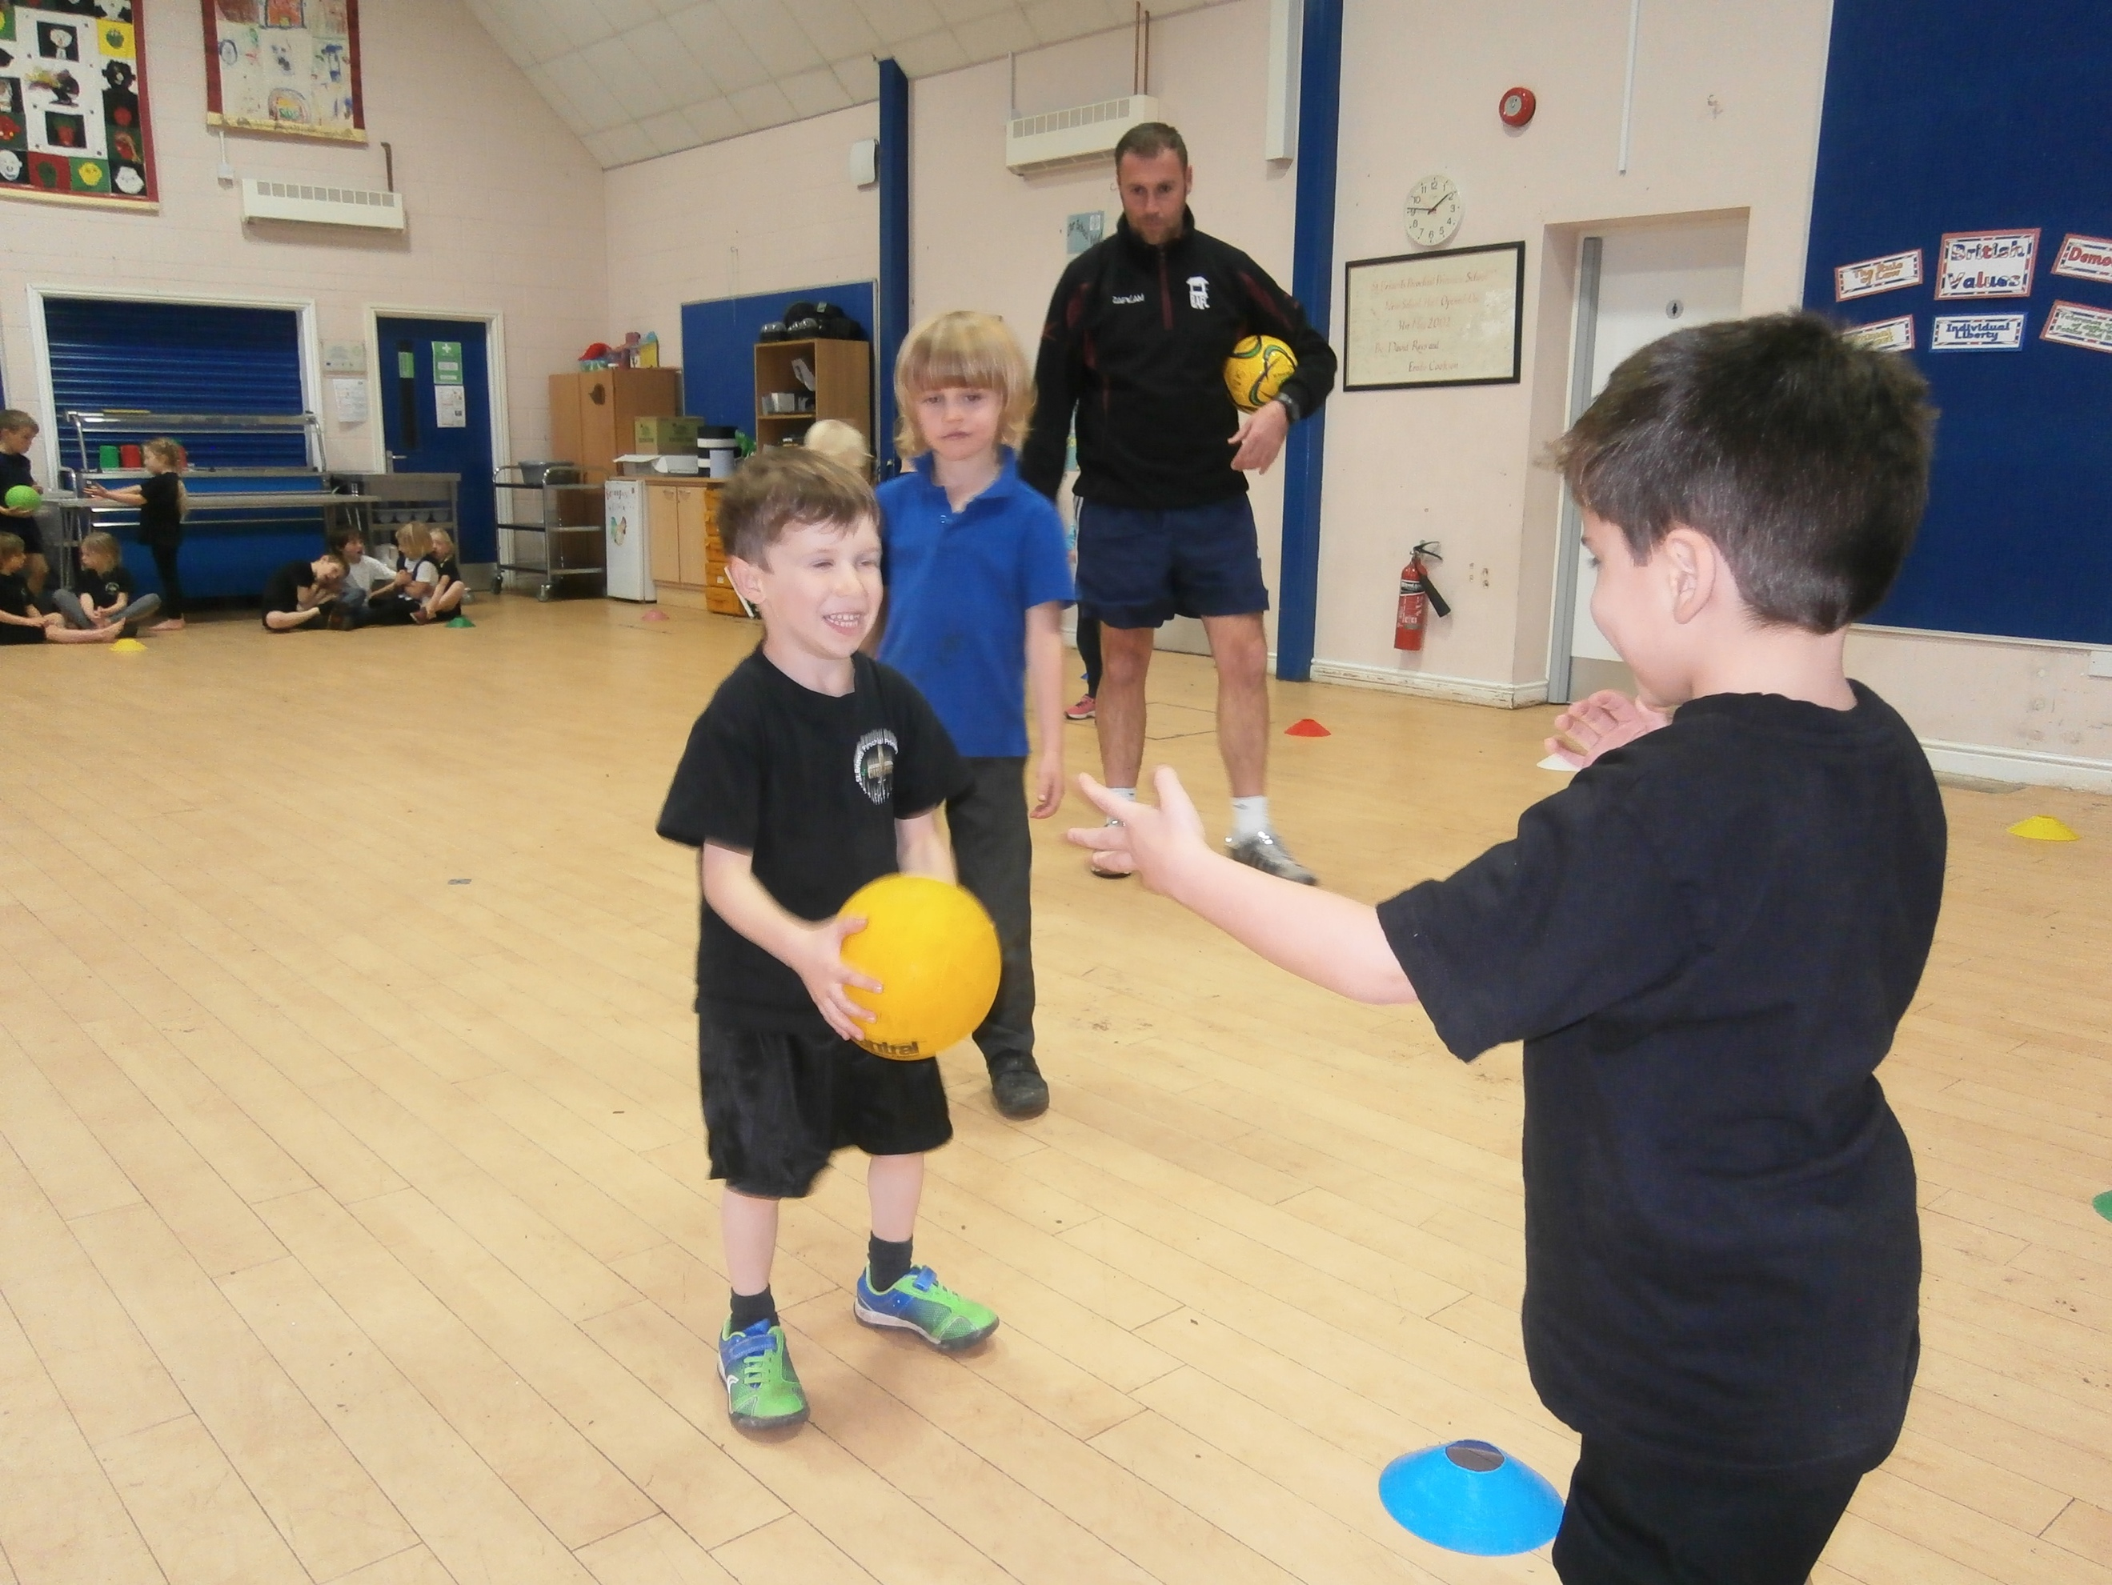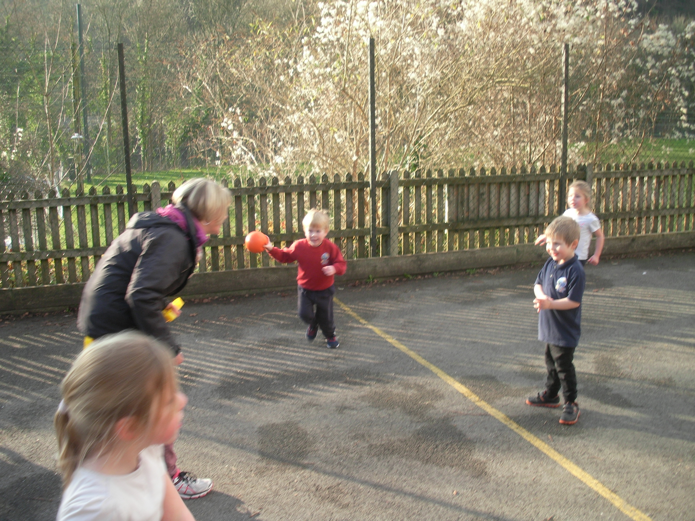

I hope you have enjoyed taking a look at our PE and Healthy Schools work this term.

During the Spring Term we will be introducing:

- Additional outside deliverers who will teach archery, yoga, fencing, lacrosse and fun fitness.
- A federation competitive team kit
- Staff PE hoodies – to be worn during PE lessons and school games events
- More taster sessions for activities that can be attended locally
- The Positive Playtime activities chosen by the pupils following the training

Additionally, both schools will be writing up evidence of the impact the daily mile has had and the outcomes of staff training on mental health first aid, that has made the staff more confident to be able to support and signpost anyone experiencing poor mental health – these interventions will be written up for the school to gain a county wide ‘Healthy Schools Accreditation.’

All that is left for me to say is, have a lovely Christmas, and I look forward to sharing our Spring Term work in April, 2019 and if you, or your children, have any comments you would like to share about any f the work you have read about on this newsletter, please share this either with your class teacher, or Mrs Helm at the next parents school forum, which I also hope to attend.

Well done everyone and Merry Christmas!

Mr Chris Powell
(Physical Education and Healthy Schools Lead)

Wye Forest Federation

